Pre-Installation settings (Turn off user account controls)
- Control Panel
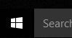
  - At the Desktop, Right Click on the Windows Start Icon and select Control Panel
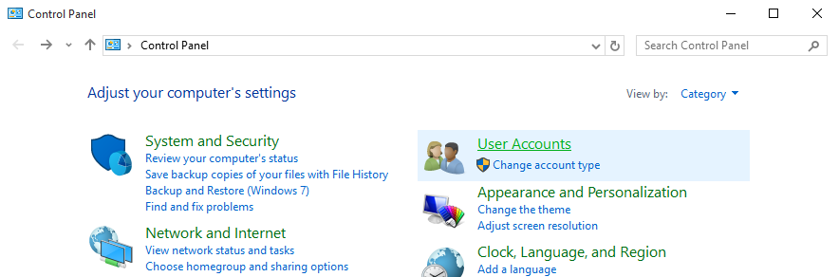
Select User Accounts

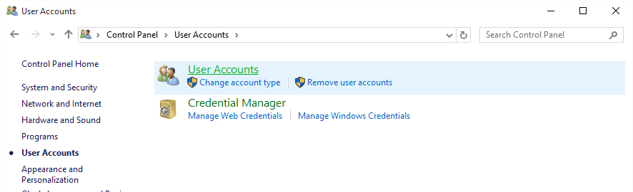
Select User Accounts again

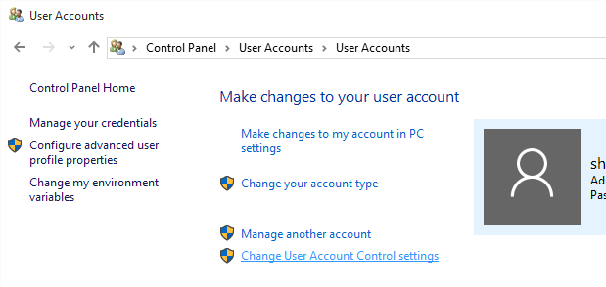
Select Change User Account Control Settings

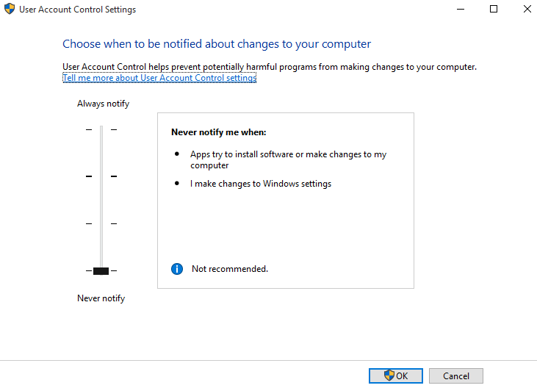
Drag Slide-bar to Never Notify

Select OK

Change PC Settings (Windows 10)
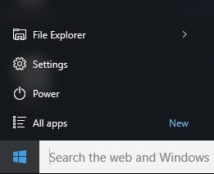
- Settings
  - Click on Windows Icon
  - Click on Settings

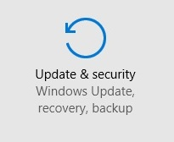
  - Click on Update and Security

  - Select Recovery
  - Select Restart Now

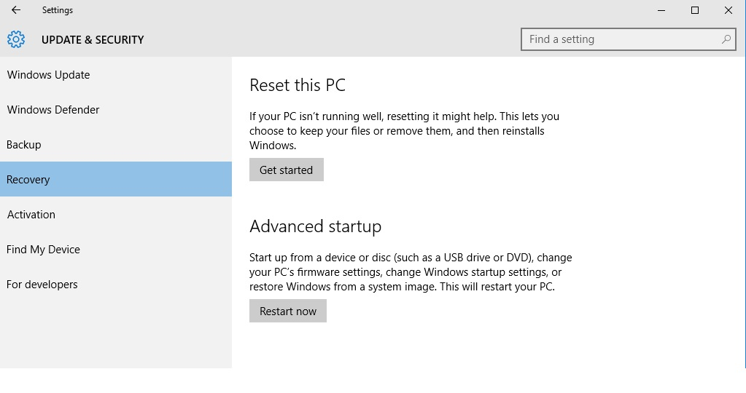

Restart Screen
- Select the box labeled Trouble Shoot
  - In Trouble Shoot Menu select Advanced Options
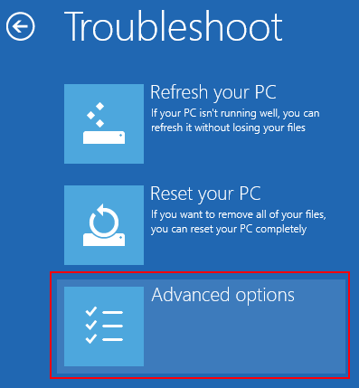
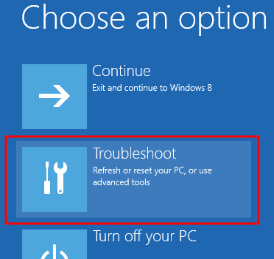

  - Select Startup Settings
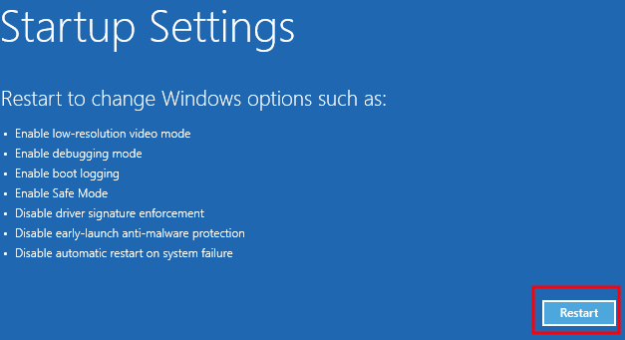
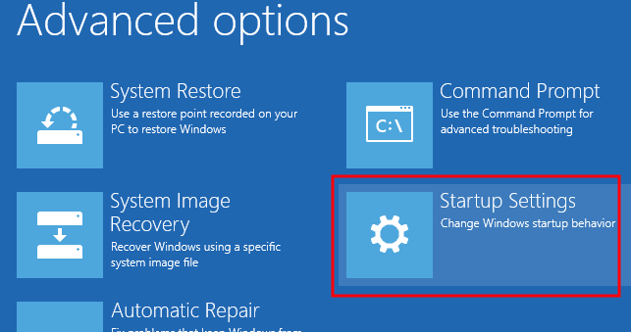
    - Under Startup Settings select the Restart box in the bottom right corner
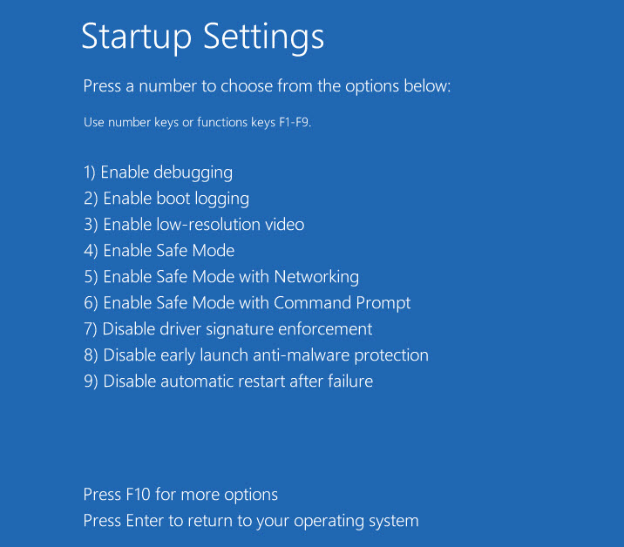

- In the next screen you will either select Disable Driver Signature Enforcement or press either 7 or F7. This will then restart the computer with the DSE disabled.

Run as Administrator
- Once computer has restarted after the DSE has been disabled, open File Explorer (Click on Windows start menu, Select File Explorer from List) (Make sure Installation Disk is Loaded)
- Select This PC from the list
- Right click on the Accutome B-Scan software disk and select Open
  - Locate Setup
  - Right click on Setup and select Run as Administrator
