Country Life-Nomad configurations

Home Page
Possibly need a link that is obvious for “Shop Now” or ‘browse products’

Add 800-456-7694 to footer on all pages

Product Page
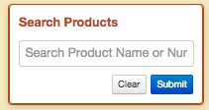
Remove ‘Search’ from ‘Search Product Name or Num’
That might solve the truncating
Leave “Search Products” as title of box
___________________________________________________________________________________________________
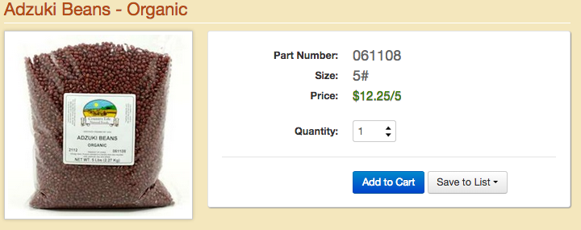

Rename Part Number to be Item Number
Remove “/5” from price, leaving only $12.25
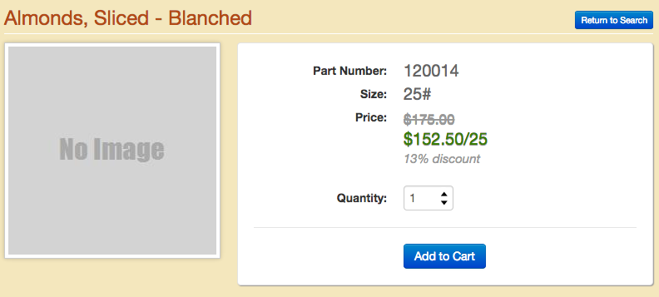

What causes this, see below
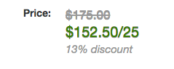

Shopping Cart

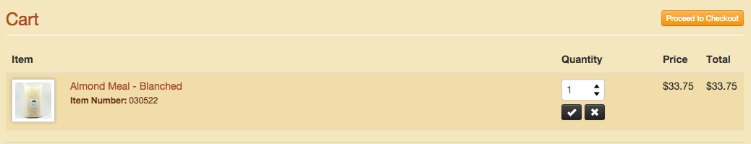

Need to add weight or size, we can discuss placement. Possibly as a column to the left of the ‘Quantity’

List Page

Replace BUY with ADD

Checkout

Need a Truck Delivery option

Order Confirmation email

Add “Thank you for your order, it is our pleasure to serve you.

